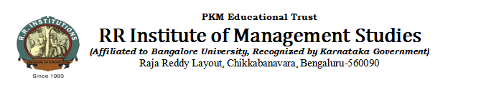

**SUBJECT ALLOCATION**

**Department of Management SUBJECT ALLOTMENT Jan-June 2025**

Dear Prof: **SHRUTHI MURTHY**

**REFERENCE**: Subject Allotment Meeting Held on

This is to inform you that the following subjects have been allocated to you. You are requested to prepare well for handling the subjects effectively and also required to submit a detailed lesson planning one week before the commencement of the classes**.**

|  |  |  |  |  |
| --- | --- | --- | --- | --- |
| **Sl. No.** | **Subject Allotted** | **Subject Code** | **Weekly Contact Hours** | **Semester** |
| 1 | **Organizational behaviour** | 2.3 | 4 | II SEM “G” |
| 2 | **Organizational behaviour** | 2.2 | 4 | II SEM “AV” |
| 3 | Indian Financial System | 4.2 | 4 | IV SEM “G” |
| 4 | International Business | 6.3 | 4 | Vi SEM “G” |
| 5 | Advertising & Media Management | MK2 | 4 | VI SEM “G” |

Thank you for your commitment to academic excellence. Should you require any additional resources or assistance, please feel free to reach out.

Best Regards

Head of the Department